**IFT 166 Introduction to Internet Networking**

**Lab 29**

**Advanced IP Scanner**

**After you complete each step, put a ‘’ or ‘x’ in the completed box**

**or**

**Answer a free response question**

**or**

**Attach a screenshot when requested.**

**WARNING: PLEASE DO NOT DO THIS LAB ON A PUBLIC NETWORK.**

1. Click this link (<https://www.advanced-ip-scanner.com/download/>) and download Advanced IP scanner from it. You should be met with this website below. The download will begin automatically when you click on the link.

1. Click “Ok” on Language Select (English is default), then click on “RUN” and hit “Next”.

1. You should now have this application up after.

1. Now, let's get into the fun part of the lab, scanning for all devices on YOUR network. **(AGAIN WARNING, DO NOT use this on a public network because it's scanning for ALL devices that are currently using the network.)**
2. Now, go ahead and click on the big green “Scan” button and it will start to show you the IP address, MAC address, its Manufacturer, and Name of all the devices on your network.

**Include a screenshot of your scan.**

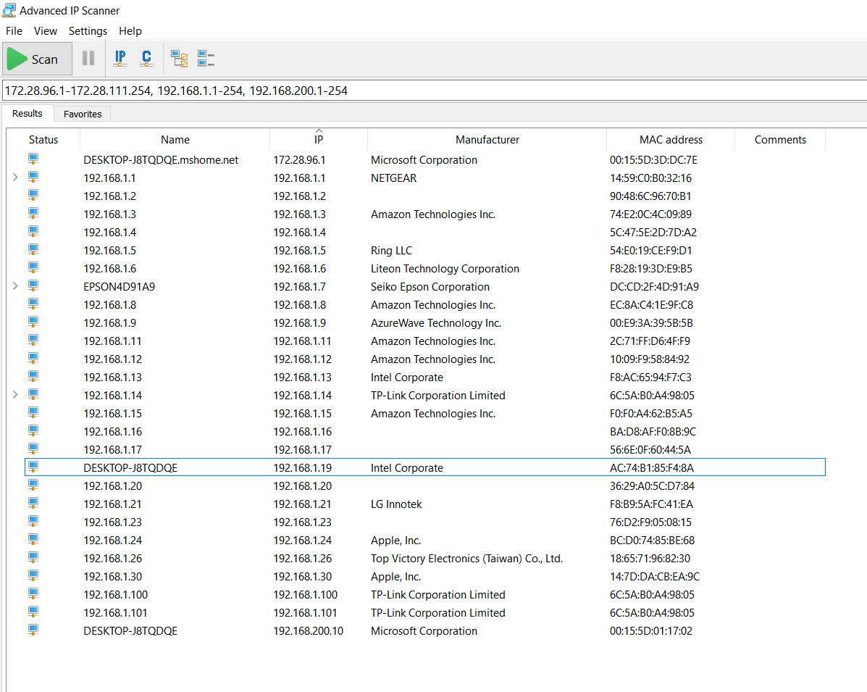

1. With all the devices, go ahead and ping some of them through CMD line on your computer. Which devices of your ping were successful?

I went through the first 10 IP addresses and they were all successful

If they weren’t successful, do you know why?

All pings I sent were successful.

Looking at the addresses from the list, can you tell which device is a router? If so, how?

Yes Netgear is the router. You can tell because this is the default gateway, as we learned the default gateway is the router IP.

Do you know what other devices are listed on this scanner (Printers, another device, etc.)?

Yes, I know the first IP is my laptop. The apple products are my wife’s Macbooks. LG is my dishwasher and the Amazon devices are my Amazon Firesticks. Ring is my Ring camera.

Now open up the CMD line and look for your computer's IP Address. Is it similar to the one listed on the scanner? If it doesn’t match, why?

It does match.



